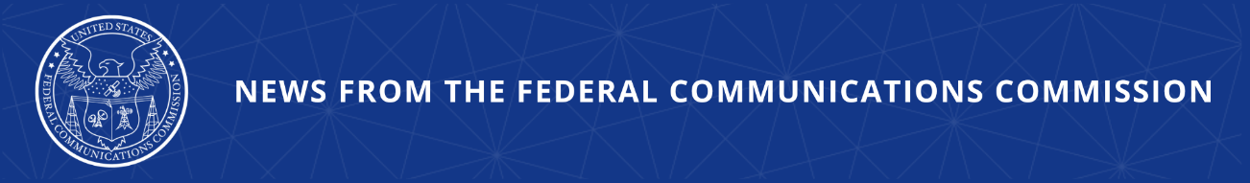

FCC Provides Guides to Help Consumers Stop Unwanted Calls and Texts
New Consumer Guides Give Instructions on Call Blocking Features Specific to the Nation’s Top Providers and Phone Models

WASHINGTON, September 22, 2026—Today, as part of its ongoing campaign against illegal robocalls, the FCC released step-by-step consumer guides that enable consumers to turn on robocall and robotext blocking and filtering tools. The “How-To” guides, available at fcc.gov/blockit, identify the tools that are part of many mobile phones’ operating systems or that come with the mobile phone service they purchase. The guides cover Apple and Google devices as well as app-based services provided by the three largest nationwide mobile providers: AT&T, T-Mobile, and Verizon. Following the actionable steps in each guide, consumers can spend a few minutes enabling features that will reduce the number of robocalls and texts they receive.

Chairman Carr issued the following statement:

“Combatting the scourge of illegal robocalls remains the FCC’s top consumer protection priority. And we are continuing to take additional steps to crack down on them. The guides we release today are yet another important step in this effort—streamlining essential information and empowering consumers to block and filter calls from their device. Thank you to the providers and manufacturers for implementing these valuable tools, which will continue to work to the great benefit of the American consumer.”

Additional Background Information:

The new guides include two device-level instruction cards and three provider-level instruction cards that identify the blocking and filtering tools the providers and device manufacturers offer and include step-by-step instructions on how to enable them. When using these tools, a consumer would pick the two cards that pertain to them—for example, iPhone and T-Mobile—and then choose which protections they would like to enable. Many of these features are available at no additional cost to consumers or are a part of services included in their individual providers’ plans. AT&T, T-Mobile, and Verizon all offer free features that allow their customers to report unwanted incoming calls and texts.

Recently, Chairman Carr released a Public Notice seeking comment on the creation of a new consumer tool, a Robocall Scorecard, aiming to empower consumers to make informed choices when it comes to their voice service provider. These new consumer resources mark the latest step in the Commission’s broader effort to attack and stop illegal robocalls at every point in their life cycle.

For tips on avoiding robocall scams and to learn more about call-blocking tools, visit: fcc.gov/robocalls.
###
Media Contact: MediaRelations@fcc.gov / (202) 418-0500
@FCC / www.fcc.gov

